Prob solving:

Factotial============

//factorials

// 5!= 5*4*3*2*1=120

//6!=6*5*4*3*2*1= 720

function factorial(number){

let result=1;

for (let i=1; i<=number; i++){

result= result*i;

}

console.log(`Factorial of ${number} is: ${result}`);

}

factorial(5);

result======Factorial of 5 is: 120

AREK babe kora jay=========

For (let i=number; i>=1; i--)

# prob 1= bmw print color and wheel

function jsonParse(show){

    console.log(show[0].variation.color);

    console.log(show[0].variation.wheel);

}

jsonParse(car);

another solution

function jsonParse(show){

    for(i=0; i< car.length; i++){

        if(car[i].name=="BMW");{

    console.log(show[0].variation.color);

    console.log(show[0].variation.wheel);

        }

    }

}

jsonParse(car);

another solution

function jsonParse(show){

    for(key in data){

        if(data[key].name=="BMW");{

    console.log(show[0].variation.color);

    console.log(show[0].variation.wheel);

        }

    }

}

jsonParse(car);

prob 2 print the name of car when color is black==============

function jsonParse(data){

for(key in data){

if(data[key].variation.color=="black") {

console.log(data[key].name);

}

}

}

jsonParse(car);

prob 3 also print their id.

Tokhon id ami nijei input dye create korbo. But ekhane key holo left side er (name/color) er moto string. Otake jodi print kori tahle 00 01 emon ashbe. Otake agge int korbo parse diye.

function jsonParse(data){

    for(key in data){

        if(data[key].variation.color=="black") {

    data[key].id= parseInt(key) + 1;

            console.log(data[key].name);

        }

    }

    console.log(data);

}

jsonParse(car);

solution==========

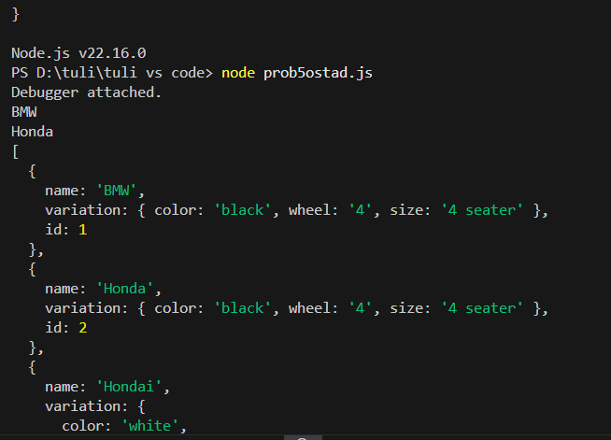

Prob 4,.,,, jei car e height ase sei car name print korbo

Agge pura ta run kore deksi jetay height nai seta undefined dekhay by running this code:

function jsonParse(data){

    for(key in data){

        //if(data[key].variation.height != "undefined") {

            console.log(data[key].variation.height);

        }

    //}

}

jsonParse(car);

then write the following=============

function jsonParse(data){

for(key in data){

if(data[key].variation.height != undefined) {

console.log(data[key].name);

}

}

}

jsonParse(car);

result=======hondai

prob 5====bmw same thakle 2tar variation merge kore print koro

function jsonParse(data){

for(key in data){

if(data[key].name== "BMW") {

console.log(data[key].variation);

}

}

}

jsonParse(car);